No Esc.

V1

Abstract

This document will contain the game design document, including sketches, concepts, code in progress and more of our game project “Geo the Hunter”

Game design document

Geo the Hunter

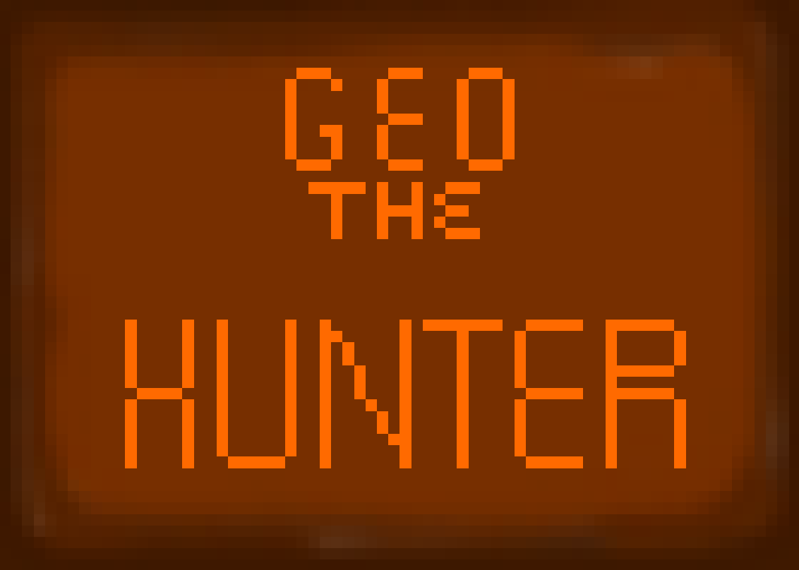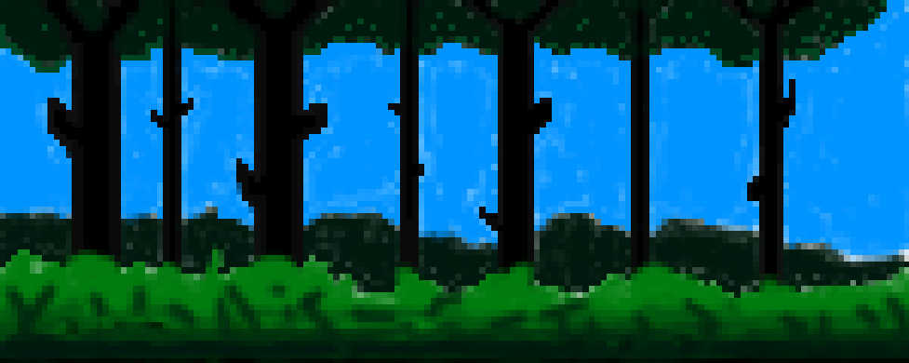

Contents

Change Log 2

Team Details 3

Game Goals 3

Story Overview 3

Game Controls 4

Technological Requirements 4

Loading Screen 5

Attract Mode Screen 5

Title Mode Screen 5

Credit Screen 6

Game Screen Structure 6

Game Loop Diagram 6

Game Class Diagram 6

Research 6

Camera 7

HUD 8

Player Character 8

Player Metrics 9

Power-Ups 9

Health 10

Scoring 10

Rewards 10

Non-Player Characters 11

Collectibles 11

Game Progression 11

Gameplay 12

Game World 12

Game Mechanics 12

Game Levels 13

Game Enemies 13

Boss Characters 14

Music 14

Sound FX 14

# Change Log

*27/04/2016 Wednesday-* Created document and team discussion on changes to the original concept. Allocation of roles. Company name. Development process.

*29/042016 Friday-* Created headings for each section of the document. Discussed ideas further.

*04/05/2016 Wednesday-* Discussed ideas in length and started making ideas, jotting them down under each heading as bullet pointed notes.

*09/05/2016 Monday-* Designs sketched and thought out. Some UI elements also sketched. Fonts TBD.

*11/05/2016 Wednesday-* Team meeting for progress update and further development of game design document. Coding is mostly finished. Placeholders are awaiting finished art designs.

*13/05/2016 Friday-* Discussed with team final details. Document is ready to be produced with all official plans and ideas to be documented. Sketches and designs have all been completed, including UI elements. First draft of game logo drawn.

*14/05/2016 Saturday-* Version 1 complete.

Game Design Document

# Team Details

We are Team K, No Esc. Responsibilities are shared between 3 members, Brennan Butler who is lead developer, Adam Sahall, lead designer and Jack Matthews, team manager and publicist.

# Game Goals

Welcome to Geo the Hunter! Geo the Hunter is a forest themed shoot em’ up arena play game in which the player strives to fight his way through the hordes of Wild Things whilst trying to escape the Wild, Wild Woods. Whilst doing this, the player will encounter tough bosses, environmental choices, rewards and tantalising weapon upgrades and a medley of traps.

The player is going to need to think to get good times completing each level for greater rewards. He can do this by cleverly using the terrain and objects as well as traps, power ups and spending his gathered coins wisely in the shop.

So what separates Geo the Hunter? Well, opposed to normal shoot em’ ups, the bosses of Geo the Hunter have some very unique counter mechanics that the player will have to learn and adapt to, giving a more skilled approach to players that want it, but a fulfilling experience to more casual or younger players.

Geo, a hard-core hunting fan, starts in his blaze orange preserver, shotgun and a smile, ready to do whatever it takes to get out of the Wild, Wild Woods, no matter what Wild Things he encounters…

# Story Overview

As discussed, Geo has decided it's the perfect day to go hunting, however, he's going to have a little bit of trouble when he sees what he's up against.

He travels to the Wild, Wild Woods.

Too far in, Geo can't go back. He encounters the creatures known as "the Wild Things", an assortment of malicious beings that have an overwhelming desire for Geo to stay...

Geo needs to find his way out of the forest, but how does he do that? Well, he has his trusty shotgun, cap and lucky underwear on, so bring it on!

Geo fights through the woods, using items that the Wild Things drops and spending his coins at the mysterious forest traveler, Elisa. Many of the areas of the woods are explored, swamps, clearings, dense brush, dark woods and more.

Geo will encounter many enemies and even some notorious bosses of the forest, before reaching the final guardian to be able to escape, however this dude seems somewhat odd...

We talked about how Geo the hunter's story should feel to a good length. A serious story felt rather wrong, and we all agreed quite quickly that it certainly was not the way forward. However, we absolutely loved the idea of this enthusiastic hunter could have quite a funny time out in the woods, nothing quite like anything else. A unique feel. So we decided it could be interesting to make it more of a comedy. Some laughs, strange things with a more casual feel just felt right. We came up with some great ideas you'll see within other areas of the game in this document.

Geo will navigate the woods by traveling from arena to arena, the terrain changing to allow the player to feel as if they really are walking around a giant forest.

The finale had to be the *pinnacle* of the comedy, so we came up with a boss that would just have the most ridiculous impression.

Geo will walk into a dark area of the forest where his last obstacle stands... Rainbow Mane, the Unicorn King. We also decided the boss needed some stupid mechanics that just made you laugh, not rage through difficulty. Also, we wanted Rainbow Mane to have some silly counters by using certain items found in the store that are totally useless everywhere else.

At this point, we just want to player to laugh as Rainbow Mane stomps them into the ground before they work out that the bubble blower is one of his secret weaknesses.

# Game Controls

Due to the game being played using console controllers, the controls needed to be simple, but each button needs to have value. As said before, we want Geo to feel like an retro game, back when an analogue stick was only seen on space ships. So we decided the direction pad was how Geo will move around mainly.

He also wields a shotgun. Geo will simply fire whichever direction he's facing, and firing will be done using the right trigger. Just a small thematic decision.

These are the main controls, and have some ideas for other buttons.

Most power ups give Geo's weapon or Geo himself a buff, meaning it's still his normal fire button, however Geo can also pick up some consumables.

Firstly, traps. Geo can hold one at a time and he deploys them in front of him when pressing the Y button.

If bought, Geo can use a melee weapon to inflict damage to nearby enemies, this is done with the X button. Geo can also use an explosive, using the B button. He can also "interact" with certain things using the A button.

We also had some ideas to make a couple of interesting ones. The left trigger could make a good dash button, causing Geo to move a short distance quickly.

We're still deciding on what could be an effective use of the R1 and L1 buttons. Like all abilities, testing will be a good phase to either balance or adjust abilities to find a balance here, but for now, we have a place holder.

R1 blocks everything 180 degrees to the right of Geo. L1 blocks the same but on the left.

# Technological Requirements

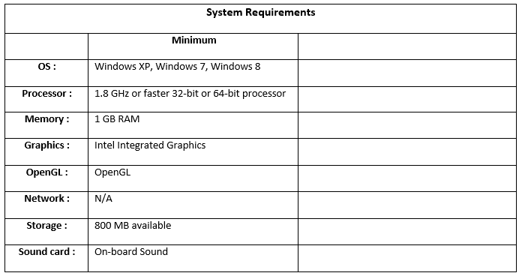

The technological requirements of Geo the Hunter are to remain low, as to encourage the output onto as many platforms as we see fit. The advantage with using Monogame it’s its versatility within cross platform and this helps us to work towards our goal. The controls are easily adaptable, and with these sort of platforms, you can expect Geo the Hunter to not only be PC, but console, both PlayStation and Xbox as well as room for mobile expansion also.

# Loading Screen

TBI

This is Geo the Hunter’s loading screens. A few pictures with some funny contents, once again simply felt right.

We chose to keep the loading screens in Pixel Art not just for ease of use, but for the player to notice breaks in the gameplay less, giving levels a smoother transition. Coupled with what Geo is doing in the loading screen captures, it makes an attempt to make loading screens a little less boring.

# Attract Mode Screen

TBI

This was quite simple to plan, and short demo gameplay for this screen is already being planned as you can see here:

We’re simply going to have some gameplay with annotations play when the start screen is left idle for more than 10-20 seconds, similar to what you might expect when you gaze across an arcade and see the attract mode screens for all of the classics. This again, fits to our thematic ideas for what Geo the Hunter will be, in all aspects. Even the demo screen, we want to feel like an arcade game.

The annotations, as seen, will be displayed on different parts of the screen with zooms to show what you can do in Geo the Hunter. All of the unique power ups, weapons and pixel forest goodness are on show, how could you resist?

# C:\Users\Adam\Pictures\Geo The Hunter.pngTitle Mode Screen



This is Geo the Hunters loading screen designs. Using a scrolling forest background with the logo static over the top, it makes for a very standard, arcade style title screen. Due to it being a cycle of a forest, it can just repeat, therefore is easily implemented and little can go wrong with it. A start button underneath the title will allow the player onto the next screen, where he/she is presented with the options on whether to start the game, enter an options menu to adjust settings or to see the credits screen, or simply exit.

The buttons all match the title in design and reflect the same feel.

We also discussed ideas for animations on the title screen. Just Geo hopping down and interacting with some of the buttons by punching or kicking them, represented by the stickman in the designs!

# Credit Screen

TBI

Credit screens are generally quite boring, but when discussing ideas, I thought back to some of my favourite gaming moments and Ratchet and Clank came to mind. I remember even the credits screen of one of the games had concepts and cool music that made it interesting to watch. I wanted to do something similar then, with Geo. Having bloopers or silly pictures as well as the game concepts and original design sketches seem a good idea to me, and we all agreed on this. We’ll simply have the roles we did, company name and our names credited on a classic scrolling screen with some of these items decorating it accordingly.

# Game Screen Structure

Here is the game screen structure. Simplistic in design, but with room for expansion if required and easy for the player to understand. No confusing amounts of screens or pop ups, just some very basic UI elements from when the game loads until the player dies and restarts and even a sneak peak of the end game screen.

We went with this structure due to its simplicity. Lots of screens just create clutter and confusion, just keeping the ones required means we can focus on the quality over quantity and make sure these screens are all functioning as intended.

# Game Loop Diagram

# Game Class Diagram

# Research

When coming up with ideas for Geo the Hunter, we did a bit of research and had a look around at different games for art style, storytelling and much more for everything in game. Inspiration is important, as it’s where creative ideas come from, so we discussed and searched up some other games/media.

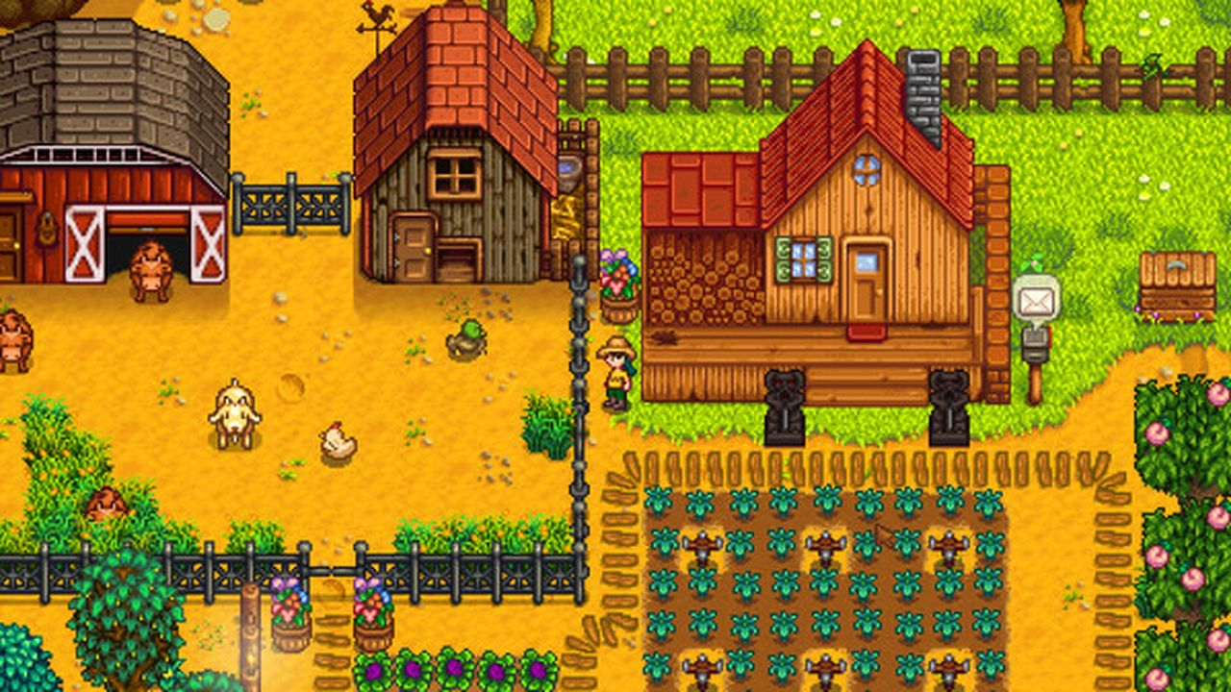In the very beginning when Jack alone was coming up with the idea for Geo the Hunter, we discussed art styles. We had both been playing a game that brought back the retro pixel art style that Pokémon did when it first came out called Stardew Valley. When talking about ideas, we also agreed that a pixel art style was really satisfying, and offered the ability to be very creative whilst not requiring art skills outside of our reach.

So we had a look at some other modern day pixel art games. As you can see on the right, Stardew Valley is a colourful and vibrant game and that’s something we wanted as well. It makes it so much easier to look at, very aesthetically pleasing. Terraria came to mind also, and as you can see below, fits the style somewhat. As well as the camera view that Pokémon uses. We also looked into a game called Boxhead, that we both played when we were younger. The game style, art style and camera also felt like it could have some good aspects within Geo the Hunter.

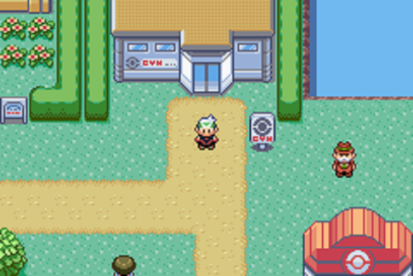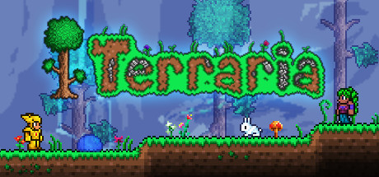

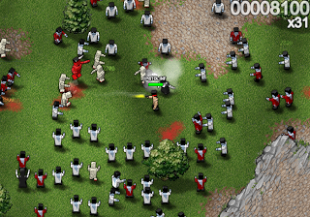

This gave us a good enough idea to work out everything else that we wanted. From this research, we could create good sprites, items, concepts, HUDs and everything else detailed in the document below.

# Camera

The camera for geo the Hunter needed to fit nicely. Cameras in games are far more important than one would usually think. It’s literally the portal in which the player sees the game through and of no use is the camera is facing a different way, difficult to use or not fitting. So we referred to our research and thought the best way forward was to simply use a docked to player camera that was top down, similar to that of other arena style games, like Boxhead, League of Legends and titles like Pokémon and Stardew Valley. It offered similarities to the arcade genres, as a lot of arcade style adventure games utilise the camera in this way.

# HUD

The HUD for Geo the Hunter was quite easy to come up with. Due to us wanting the focus to be on gameplay, we used very simplistic and minimalist approach that allows the player to see everything they need to, but without overpowering what’s going on in the main game screen. Here is a design for what you would typically see in game.

As you can see the health bar simply follows the player’s head, meaning you don’t have to take your eyes off of what you’re doing to track your health, unlike some games where the health bars are situated in corners or the bottom of the screen.

We talked about mob health and using the same system or a targeting frame to see what each mob has in health, but actually decided against it for gameplay reasons. We wanted to encourage the players to pick up and learn how many shot/how much health the mobs have from simply playing, and that knowing exactly how much health a mob has was detrimental to the big picture.

Other than this, there will be a small bar, as seen in the picture, that has the tools available to Geo, with their key bindings next to them, so the player has an idea from the get go. No tutorial will be required. Power up timers/charges are displayed just to the right of this.

Another little thing to mention that we discussed and thought was a good idea is moving the UI with the position of the character on the map. So when you’re at the top of the map, opposed to the HUD taking up the button and getting in the way, it will anchor itself to the top. As you pass into the other half of the map, the HUD will then anchor itself to the bottom. This is simply to ensure the player isn’t missing things due to the HUD, however, if during testing this is too disorientating or we can’t put some internal cooldown on it to reduce the spam, then we will come up with another idea.

# Player Character

This is Geo, our main character. As outlined in the overview, Geo is an enthusiastic hunter with a loose grip on common sense. His cap and orange blazer do a good job of highlighting this! He starts with his trusty shotgun (the staple weapon of any hunter) and can run about in the world and has some speech functions to interact with the player. He has been designed in our pixel art style and I think he looks pretty finished on what we want him to look like. His counterpart brother, Leo, will just have inverted colours so there aren’t any rivalries between players! There are also some sketches:

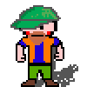

# Player Metrics

With the game being arcade style, we want it to feel fast, but not so fast that the player feels under awful pressure, but not slow enough to lose that hectic feel. This will require some fine tuning, but we think it’s possible. By making each map an average of a 2 minutes, it should keep quite a fast paced feel and without the levels being time event based, it will also mean there is no waiting around. Once you’ve defeated the enemies, you’re done with that level and can move on.

This should also give the player time to use the map to its full potential and take advantage of our game mechanics, explained in more detail in its section.

Lastly, we feel that a good idea and one worth mentioning is to use an “intro” timer at the beginning of the level. Due to Geo the Hunter being arena based and with our particular game mechanics, 10 seconds at the beginning of each level will be spent with no music, giving it that “calm before the storm” feeling and giving the player a chance to prepare and see the map advantages. Of course, they could just spend it AFK if they wanted!

# Power-Ups

Geo’s standard shotgun is good, reliable. But during his time in the Wild, Wild Woods, he made need to get his hands on some more powerful weaponry! So we came up with the power up system. His standard shotgun will shoot one round every 0.5 seconds that’s a single projectile.

Originally, we were thinking that Geo would just purchase better weapons and keep them, but it didn’t feel particularly retro, and we felt classic power ups were better, not to mention we envisioned this once, normal hunter to reach endgame with Black armour and an automatic rocket launcher and thought “perhaps not”.

So regarding power ups, we decided temporary weapon upgrades, on use traps and modifiers were the best way to go. For example:

Geo could pick up the 12 Gauge power up, which makes his shotgun fire 8 projectiles in a wide cone in front of him, giving it area of effect capabilities. Also, due to power ups being able to stack, he could also pick up the Explosive Ammo power up, which causes each projectile to explode on impact, causing yet more area of effect damage. These power ups will be fairly common and last around 10-12 seconds. Meaning moments where your weapon becomes crazy can happen often.

So traps, Geo can also pick them up. They drop like power ups, but do not have a timer. It’s not worth holding them forever, but it does allow for some more strategic placement (we can tune them eventually to reach a place where they should be just thrown down in a precise place to reach maximum effect). One trap for example, is the standard Bear Trap. It simply deals a large amount of damage to anything that walks over it. There is also an Ice Trap, which releases a cold burst that freezes the ground around it, making enemies and Geo walk slower in that area. This can be coupled things like logs or water (see mechanics section) for a double slow effect.

Lastly, modifiers. These will change Geo himself. For example, Geo can pick up an Everyman for himself! Power up that makes him run much faster for 10-12 seconds. Or Twitchy Finger which makes him fire at double rate (1 round per 0.25 seconds). These again, can stack with weapon power ups, so yes, you can have an explosive, spread shotgun being fired at 4 rounds per second for a short period of time (if the Gods of chance are with you). This should be a rare occasion, but happen often enough for the player to see them and to use it effectively within the level.

# Health

The player’s health was quite an easy one to settle. We simply decided the player would have 100 hit points and each different enemy would take off different amounts. We did toy with the idea of making Geo a one shot kill, but due to balancing in the later levels and where we wanted to go with that, we decided to use a hit point system instead.

# Scoring

Our scoring system is very much interlinked with the rewards. The scoring system as such we were on the fence about. We were unsure what we wanted the player to collect, so we went with a very classic idea of just gold coins. Our other scoring system is done by the time completed for each level. This then places the player in one of three brackets depending on the time they completed it in. There is also a screen in which the player can track these brackets and times. This allows the player to analyse their performance and either do better or be proud of where they are. I’ll explain more on the specific details in the reward section below.

# Rewards

The rewards system simply carries on from the scoring system, in the ways that it actively rewards the player.

Firstly, the time rewards. The quicker you clear the level, the higher the brackets. At the moment we’re looking at just using 3 brackets, a bronze, silver and gold. Each level will have a unique trophy for each bracket, bronze being the worst, gold being a really cool trophy but all of them rewarding in some manner.

Also, the player is rewarded through the power system, as we discussed earlier. This creates moments of euphoria as the player just demolishes enemies with stacked power ups.

Lastly, you have the coins, as touched on in scoring. This can obviously keep score, but it also rewards the player by allowing them to buy upgrades from the shop, covered in more detail in the NPC section. This gives players an incentive to collect coins. Due to there not being an official scoring system, player power spikes help determine this score and the rewards are the easiest place to show this to the player base.

# Non-Player Characters

We spit balled ideas for this, as we were unsure whether it was a good idea or not and we’re still thinking about whether it’s going to be implemented. The idea was to accompany Geo through the game, almost like a lucky power up drop that was permanent, a Stumbler called Nigel that you’ll encounter at the end of one of the levels. He’ll randomly spawn and simply state his discomfort with what the Wild Things are doing and wants to help you to escape the woods.

The only other NPC we were thinking of adding was Elisa the forest traveller, who’s going to be our shop NPC. It was going to be her spawning at the end of each level, but decided having a shop screen between each level was easier, making sure the player never misses the opportunity to upgrade if they can’t find the NPC. It would simply be easier and safer. Not to mention, it allows us to make a game screen for it.

# Collectibles

Here I’ll go a little more in depth about the trophy system from the rewards section, as this is what’s going to double as our collectibles. Each level’s trophy will be unique and therefore offer a “collectible” aspect to them. For example, bronze trophies will be a framed acorn, a silver trophy will be a pair of antlers on a trophy and the gold might be crossed shotguns. Each level will have its own trophies and there will be a collecting screen in which you can see all of your trophies. To get them requires you to defeat the level in the time brackets, so for 2+ minutes, bronze, 1-2 minutes silver and under 1 gold. Each level will have your trophy in a little box next to all the other levels. Can you collect all of the gold trophies?

# Game Progression

* The game progression, as described, is quite easy to see. Level and difficulty progression is how we’re going to map this out, giving the players the want to progress.
  + Linear level progress
  + Ideas for bonus levels, secret areas and the like
  + The shop offers the player a power curve

The game progression compliments the next section, gameplay, really well. It’s a very conventional yet effective progression tactic. We chose to utilise a linear levelling system to allow the player to see a clear path of progression. In Geo the Hunter, you simply complete level after level and each level is on an exponentially increasing difficulty curve. For example, on the first level, you might encounter 5 enemies. On level 10 it’s 100.

This offers the player yet more reward in the form of progression and difficulty and makes it tougher to achieve those gold trophies, making players really strive for it.

The shop and power ups in general offer the player a power curve, rewarding them with strength and the ability to take on more enemies. The difference between someone playing on level one and ten will be a considerable power spike. This is yet another way to reward the player and offers progression within the game.

# Gameplay

We’ve covered many areas of Geo the Hunter, but what about the gameplay? Well this is where we want to shine. We want to give players an engaging, tough yet comical experience in which they feel tested, hectic but above all simply enjoy themselves and laugh with friends as Geo gets utterly surrounded and ultimately defeated. Or being crushed by a giant unicorn of course.

So Geo the Hunter is an arena style game in which the player is swarmed by enemies and must use the environment, weapons and initiative to defeat enemies and progress through the game. Geo also encounters bosses, which will use unique mechanics that the player has to deal with to defeat the boss (covered more in Boss section).

We discussed that the overall gameplay really should feel like the player was actively making choices to increase their performance and gives a large skill ceiling if required. However, if you want to run and gun, that’s totally up to you and you can do that too. The power ups also lead to some cool moments of gameplay in which the player can do some ridiculous things. This is what we wanted to happen and are very glad that it did.

# Game World

The game world was discussed in length and we think we have a clear and concise idea on what we want. As covered, the game world takes place in the Wild, Wild Woods, and as such, we have reflected. Using a basic map with terrain and sprites to hand flora and fauna, it creates an alive feel that really feels like a forest. There’s lots of different terrain and areas as well, so Geo feels like he’s progressing through the forest as he goes through the levels. Swamps, rivers, clearings etc.

# Game Mechanics

The game mechanics are what’s quite interesting. We created some ideas to really make the player feel as if they’re fighting something opposed to pressing buttons on a video game. Too many games are just shoot to win, but we’re going to instead create mechanics for the player to require certain things to defeat enemies and bosses. Bosses will also have some unique mechanics, explained below in the boss section.

Within the terrain, we decided to add things that would let the player control the flow of combat. They can do this in a few different ways. For example, large fallen logs, swamps, water and bushes all cause units that pass through them to be slowed right down and effects like this stack (50% on a 50% slow resulting in a 75% slow). This coupled with the 10 second preparation time at the beginning of each level means the player can strategically set up and prepare for the enemies that are going to spawn. Also, routes can be planned to counter certain things and much more. This means a good player will be able to achieve those trophies for shorter times, where as players just standing out in the open might well still win, but not at the same amount of time as the other player. Also, we were thinking thorn bushes could be in certain places, damaging units and slowing them.

So different mobs have different mechanics that players will have to deal with, which will be covered in more depth on the enemies section. But the general idea is for them to have unique abilities.

Bosses will also have similar abilities, but much harder and less forgiving.

Lastly, simple mechanics such as Geo’s place-able traps and his block mechanic will be implemented.

# Game Levels

Each level will consist of similar things, but in ever so slightly different biomes as such. We discussed about something other than a forest, but for consistency, we decided it was best to just travel within the Wild, Wild Woods.

Each level will have some game changing terrain (the water, swamps, thorn bushes etc.). The level will start with a 10 second timer that allows the player to prepare defences (or an offence if they so wish) to take on the spawn of enemies that will happen after the first 10 seconds. Early levels will have 3-5 enemies; later levels will have 100-200 enemies. The player must then defeat these enemies to go to the next level. Defeating enemies gives a chance for a power up to drop, greatly increasing power and making the level easier to clear. This will result in a reward at the end of the round depending on how quickly the player triumphs. As the levels progress, Geo will move into different areas of the forest. Also, between each level, you will bump into Elisa the Forest trader, who sells various upgrades for your shotgun, simple damage buffs, multi-shot etc.

Another idea we were thinking about, is making this all transpire in the time of 1 day. Starting early morning and finishing at night. Meaning as the levels progress, so does the time of day. The last level will be at night.

# Game Enemies

So the idea behind the enemies (Wild Things) is to have a variety of them that do different things to make the player learn and understand what each does and come up with different ways in which to tackle them. The general mobs, Stumblers, Twines, will spawn in large amounts early and late into the game. However, things like Orcs will have a guaranteed number spawns, like other difficult enemies, as you reach certain levels, like an introduction as such. Let’s go through some of the enemies.

* Crowmads. Dark, nasty beings that inflict damage from range and will “haunt” the area upon death (they create a large area in which if the player enters, will take large amounts of damage).
* Orcs. Savage humanoids who live in the Wild, Wild Woods. Rarely seen, but if you annoy an Orc, they will eventually go into a rage, dealing massively increased damage and moving much faster, almost impossible to run from.
* Stumblers are just forest creatures who don’t quite have the grip on the whole walking thing. They deal a fair amount of melee damage, but if you get caught by something that can barely walk can you blame the Stumbler?
* Barry is the name of a very rare animal… the stick man. Barry will simply run at you with his ninja skills, trying to inflict heavy melee damage.
* Twines are small forest vines that have been disturbed by Geo’s presence. They do low amounts of damage and are easy to kill.
* Venus-Fly-Walkers will fire ranged projectiles at the player in a straight line and will explode in a fan of thorns on death.

For an example of how they are in game, the Venus-Fly-Walker upon death will release thorns around them in a 3 metre area of effect, damage the player or enemies. Stumblers will simply die. Orcs, when at 30% health, will enrage and deal 100% more damage and move 100% faster. Meaning you’re going to need to take them down quick!

# Boss Characters

We were very hesitant to actually attempt bosses in Geo the Hunter and we kept spinning ideas for how we might do it and then deciding against and then for until we finally decided, why not?

Bosses won’t be anything serious, comical figures such as unicorns, giraffes and other mythical of out of place creatures. However, they will have mechanics that the player must think about to succeed.

We discussed simple things, such as frontal cone attacks you must move away from, area of effects, shields that Geo must surpass and more. Let’s look at one boss in particular for some clarity.

The last boss of Geo the Hunter will be Rainbow Mane, the Unicorn King. He will have the following abilities:

* Graceful Stomp- Rainbow Mane causes a large smash in a cone in front of him, killing anything caught within it.
* Magnificent Dash- Rainbow Mane goes into a frenzy, trampling very fast around the map, killing anything caught in his path.
* Suave Kick- Rainbow Mane kicks everything around him, killing anything he hits.
* Only the Worthy- Rainbow Mane is covered with a shield that only beautiful things may surpass (bullets will not harm him).

We thought this would be such a fantastic ending, not to mention the only way to kill him is without bullets… maybe that bubble blower in the shop will be useful after all!

We were thinking about implementing a boss of some sort every 5 levels. Meaning we could certainly get a few in.

# Music

We’re thinking about having 2 different tracks for Geo the Hunter, but will be decided when I start writing it. One hectic piece for the level and main menu and a more standard normal track for when he’s in the shop.

It’s very important that the only sound at the 10 second preparation phase is FX, not music. It purveys that “calm before the storm” feeling.

All of the music will be 8-bit to match the art style and arcade feel of the game.

# Sound FX

The sound effects in Geo the Hunter will be quite important, due to being in a forest. There’s lots and lots of different sounds that come together to create the forest feel. Also, things like rustling bushes and trees can add a good effect. Footsteps will also be going across multiple terrain, so those changing with the terrain will be quite a good immersion tactic. Grass sounds like grass, water sounds like Geo is wading etc.

Enemy sound effects will remain quite simply. Chirps, sounds. Nothing nasty, as the low age rating will be broken.

We decided against vocals in the game and instead, have text bubbles with that blipping noise you see in other 8-bit pixel art games. It adds that retro feel that we got from Pokémon and Stardew Valley.